CSE338: LAB 4

GitHub link:

# Screenshot of failed test (education radio buttons)

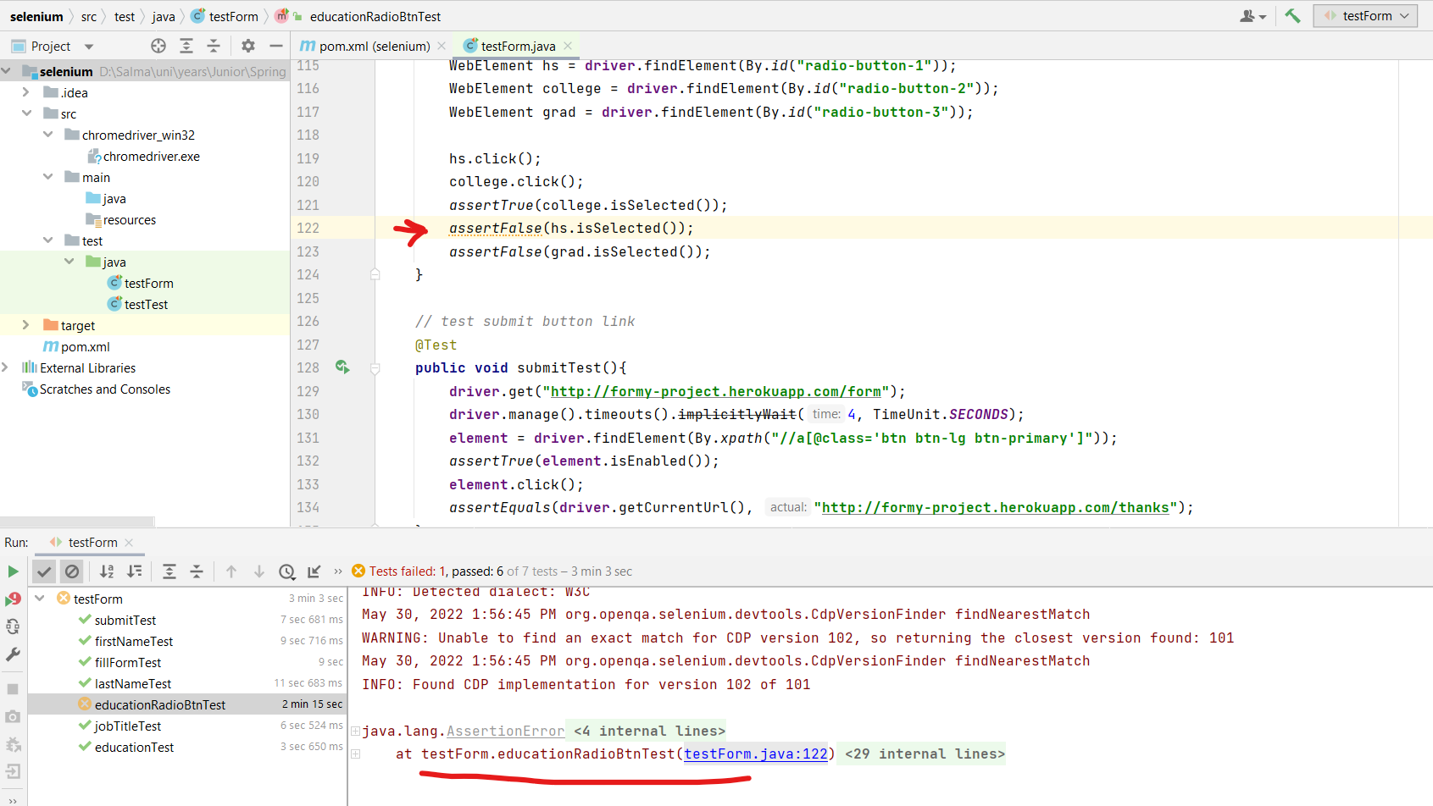

# Screenshot of filled form

